Application for Scholarship
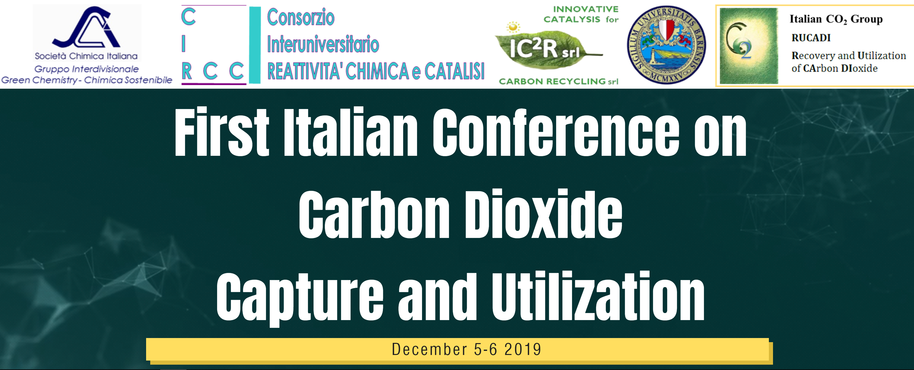
Salone degli Affreschi - Università degli Studi di Bari Aldo Moro
- Piazza Umberto I - 70121 Bari (Italy)
circsrl13@gmail.com

Please complete this form then print, sign, scan and send to: circsrl13@gmail.com along with supporting letter signed by your tutor.

- Personal and Contact Information
Title
First name
Family name
Date Birth dd/mm/yyyy
Nationality
Passport/IC number
Country of Residence
Address
Street, Number
City, State, Postal Code
Country
Email
Phone number
Mobile number
SCI Membership Number |  | Division of:

- To be eligible for the Scholarship, an applicant:
- | must complete this Scholarship Application Form and return it, as instructed, no later than 15 November 2019
- | must have submitted an abstract for flash or oral presentation by 15 November 2019
- | must have submitted the tutor supporting letter by 15 November 2019.

Signature................................................................................ Date: ……………………………..

